# Gamma Ray Ranging 伽马射线测距

朱科衡(PB21020614) 徐嘉路(PB21000212)

指导老师：蔡俊

**Abstract:** The application of gamma ray ranging in spacecraft landings is investigated in this study. Secondary gamma rays, characterized by high frequency and energy, are evaluated for their penetration capabilities, a crucial factor in spacecraft landing accuracy and safety. The experimental setup comprises a gamma source, detector, and copper sheets. Key challenges include photon obstruction and finite copper size, addressed through the Monte Carlo method for data correction. Results indicate the potential of gamma ray altimeters in spacecraft landings, demonstrating a significant improvement in landing reliability. The study contributes to the field of space exploration by proposing an alternative method to traditional landing sensors, enhancing the safety and accuracy of spacecraft descent.

**Keywords**: Gamma ray ranging; Gamma ray altimeters; Spacecraft landing; Monte Carlo method; Data fitting

#### Introduction

The realm of space exploration is continually evolving, with technological advancements opening new frontiers and posing unique challenges. In this dynamic context, the precision of spacecraft landings emerges as a pivotal factor, especially in missions involving celestial bodies with little or no atmosphere. Traditional methods, such as Doppler radar and laser altimeters, while effective, often face limitations due to atmospheric conditions or surface obstructions like dust. This study proposes an innovative approach to enhance the accuracy and safety of spacecraft landings: Gamma Ray Ranging (GRR).

Gamma rays, known for their high frequency and penetrating power, offer a novel solution for spacecraft altitude measurement during the critical Entry, Descent, and Landing (EDL) phases. Unlike other forms of electromagnetic radiation, gamma rays can penetrate dense materials, making them less susceptible to environmental factors that typically impair conventional sensors.

This paper delves into the application of gamma ray ranging in spacecraft landings. By harnessing the penetrative properties of secondary gamma rays, we aim to demonstrate the feasibility of using GRR as an alternative to traditional landing sensors. The study encompasses a detailed exploration of the interaction of gamma rays with various materials and their potential in enhancing landing precision. The experimental setup, involving a gamma source, detector, and copper sheets, addresses challenges such as photon obstruction and finite copper size. These issues are mitigated using the Monte Carlo method for data correction, ensuring the reliability of our findings.

Through this investigation, we strive to contribute to the field of space exploration by offering a method that enhances the safety and accuracy of spacecraft landings. Our results indicate a significant improvement in landing reliability, paving the way for future applications of gamma ray altimeters in space missions. This advancement promises to elevate the standards of spacecraft landing technologies, marking a step forward in our quest to explore the unknown realms of space.

#### 1 Exploring the Frontiers of Gamma-Ray Ranging

#### 1.1 Gamma Rays

Gamma rays are a form of electromagnetic radiation, like light and X-rays, but with much shorter wavelengths and higher energies. They are produced by various processes in the universe, including the decay of radioactive substances and certain types of nuclear reactions [1]. Gamma rays can penetrate most materials [2], making them useful in medical imaging and treatment, as well as in industrial applications.

#### 1.2 Penetration of Matter

Gamma rays possess a unique ability to penetrate matter due to their high energy and short wavelength. Unlike alpha and beta particles, which are charged and can be stopped by relatively thin materials, gamma rays are neutral and interact less frequently with atoms. This allows gamma rays to traverse dense materials such as lead and even human tissue. The extent of penetration depends on the energy of the gamma rays, with higher-energy gamma rays having greater penetration capabilities. This characteristic makes gamma rays invaluable in various applications, including medical imaging, industrial inspections, and certain types of radiation therapy [3].

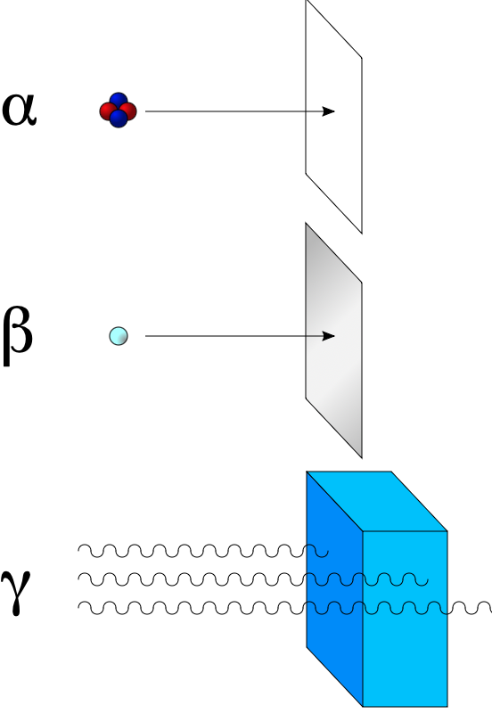

#### Figure 1. Alpha radiation consists of helium nuclei and is readily stopped by a sheet of paper. Beta radiation, consisting of electrons or positrons, is stopped by an aluminum plate, but gamma radiation requires shielding by dense material such as lead or concrete.

#### 1.3 Matter Interaction

The interaction between γ photons and matter mainly includes the **Compton effect**, **photoelectric effect**, and **pair production** [3]. When γ photons undergo non-elastic collisions with extranuclear electrons of atoms, a portion of the energy of the γ photons is transferred to the electrons, causing them to be ejected from the atom as recoil electrons. The process in which the energy and direction of the scattered photons change is called the Compton effect. When low-energy γ photons interact with bound electrons in the atoms of a substance, the photons transfer all their energy to a bound electron, causing it to be emitted. The disappearance of the incident photons is known as the photoelectric effect. As the energy of the incident photons increases, the absorption of the photoelectric effect quickly diminishes, and the Compton effect gradually weakens. When the photon energy exceeds 1.02 MeV, pair production may occur, where the photon is completely absorbed, leading to the creation of a positron-electron pair.

For γ photons of different energies and stopping media, the roles played by the photoelectric effect, Compton scattering, and pair production differ. Figure 2 illustrates the relations between these three effects and the atomic number (Z) of the absorbing material as well as the photon energy.

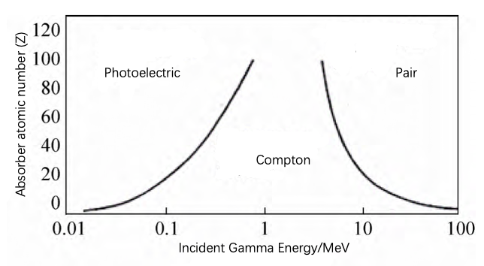

Figure 2. The relations between the three effects and the atomic number of the absorber, as well as the photon energy.

According to Figure 2 [3], it can be observed that for low-energy γ rays and absorbers with high atomic numbers, the photoelectric effect is dominant. For medium-energy γ rays and absorbers with low atomic numbers, Compton scattering is predominant. For high-energy γ rays and absorbers with high atomic numbers, the pair production effect is dominant.

In our investigation, photons with an energy of 0.662 MeV are released by the γ source ( $^{137}$ Cs). When these photons interact with electrons in copper (Cu), characterized by lower atomic numbers, the predominant process is Compton scattering, accompanied by a minor contribution from the photoelectric effect.

#### 1.4 Spacecraft Landings and Advantages of Gamma Ray Ranging

Manned spaceflight and deep-space exploration involve critical Entry, Descent, and Landing (EDL) processes, crucial for returning to Earth or landing on celestial bodies [4]. These processes necessitate precise control of landing speed, especially for manned spacecraft where personal safety and spacecraft reliability are paramount.

One key element in EDL is the retrograde landing rocket, which employs functionally graded materials to enhance its properties. Traditional landing sensors, such as Doppler radar, radar altimeters, and laser altimeters, are used to measure altitude during landing. However, these sensors can be significantly affected by atmospheric conditions [5-6]. during Earth landings or by dust during Mars and Moon landings [7].

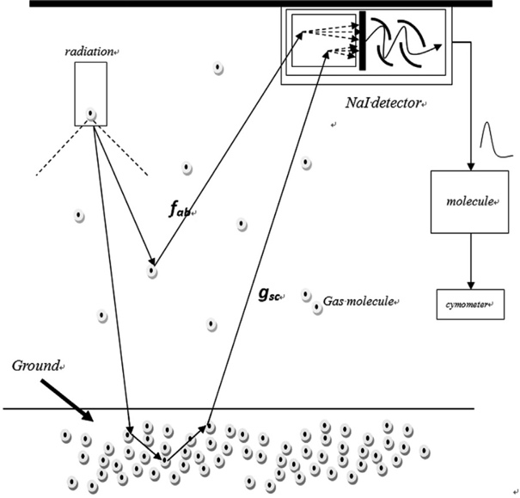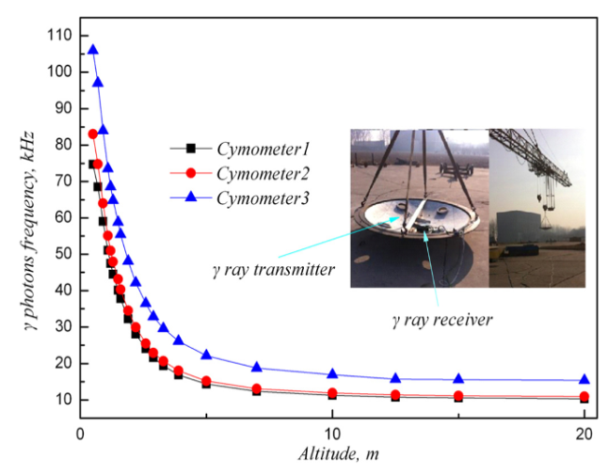Notably, the γ photons altimeter, exemplified by the Russian "KAKTUS," presents a valuable alternative [8]. This technology emits gamma photons over an area and accurately measures the altitude by receiving the scattered photons, allowing for controllable landings, even at low altitudes.

Figure 4. The static h-f curve measured in previous experiments by Liu et al.

Figure 3. The physical process of altitude measurement.

In contrast to laser or mechanical touch altimeters that measure altitude for specific points, the γ photons altimeter (Figure 3 [8]) can measure average altitudes, reflecting the real landing point within a certain region. An additional advantage lies in the strong penetrability of γ rays, minimizing interference from dust raised by the engine during the landing process.

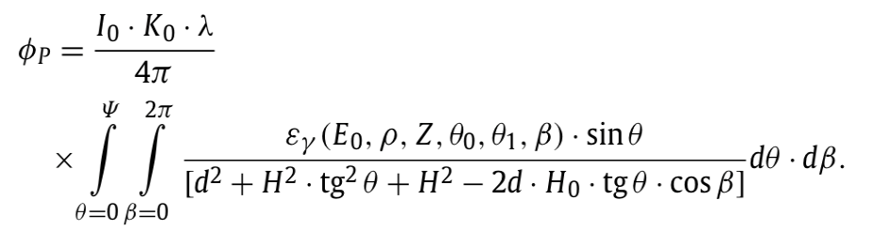In a previous study the density of gamma photons captured by the NaI detector is expressed as:

In theory, the calculation of $ϕ_{p}$ allows us to derive an h-f curve, where ' $h$' represents altitude or distance to the ground, and ' $f$' signifies the frequency, indicating the number of gamma photons detected within a second. Nevertheless, applying the aforementioned formula directly proves challenging in the context of a practical altimeter system, owing to its complexity. Therefore, the $h-f$ curve is alternatively established through experimental means, as depicted in Figure 4 [8].

#### 1.5 Objectives

The objective of our study is to explore the feasibility and accuracy of using gamma rays for spacecraft landing applications. Specifically, the study aims to:

1. Investigate the Penetrative Properties of Secondary Gamma Rays: Understand how secondary gamma rays interact with different materials and their ability to penetrate surfaces, which is crucial for accurate ranging.
2. Evaluate the Efficiency of Gamma Ray Ranging: Assess how effectively gamma ray ranging can measure distances, especially in the challenging environments encountered during spacecraft landings.
3. Overcome Experimental Challenges: Address and find solutions for specific challenges such as photon obstruction and the finite size of the copper reflector used in the experiment.
4. Apply Corrective Techniques for Enhanced Precision: Utilize the Monte Carlo method to correct experimental data, aiming to improve the accuracy and reliability of gamma ray ranging measurements.
5. Demonstrate the Potential for Spacecraft Landing Applications: Show through experimental results and analysis that gamma ray ranging can significantly enhance the precision and safety of spacecraft landings, contributing to the advancement of space exploration technology.

## 2 Experimental Approach

#### 2.1 Experimental Arrangement

The apparatus is listed as follows (see Figure 5).

* Gamma Source ( $^{137}$ Cs): Emits $γ$ photons with an energy of 0.622 MeV.
* Detector (Scintillation Probe): Detects and converts $γ$ photons into electrical signals for analysis.
* Lead Brick: Positioned between the source and the detector, serving as a barrier that prevents direct penetration of $γ$ rays to the detector.
* Copper Sheets: Stopping media for $γ$ rays, primarily undergoing Compton scattering.
* Multichannel Data Processing Software: Efficiently manages data from multiple channels, enabling analysis and interpretation. Provides the intensity of photons with varying energy, generating $γ$ spectra (see Figure 6).
* Computer: Central processing unit for data acquisition, storage, and analysis, coordinating information from various components in the experiment.

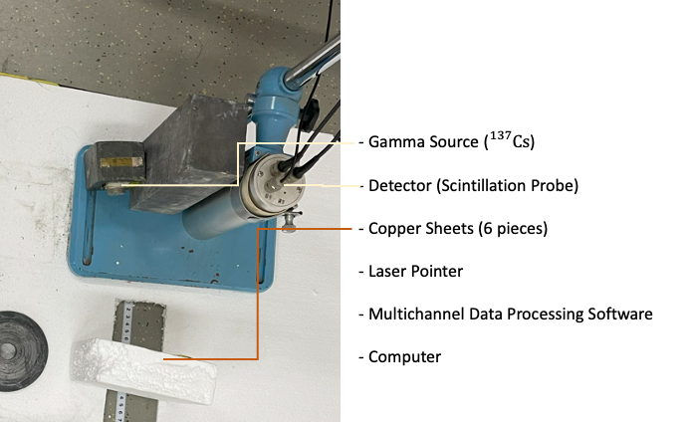

Figure 5. Image of experimental arrangement.

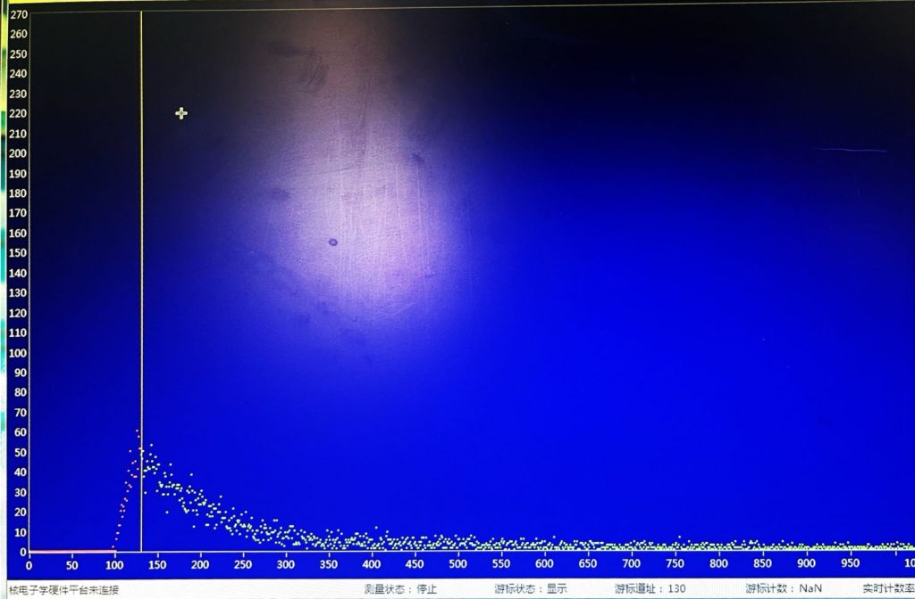

Figure 6. Software-provided spectrum: X-axis corresponds to channel number (proportional to photon energy E), Y-axis to intensity (proportional to photon count).

Ensure precise placement of the source, detector, and lead brick as depicted in the image.

1. Placing the lead brick too close to the detector obstructs most scattered rays.
2. Placing the lead brick too far back allows unwanted $γ$ rays to leak directly towards the detector, intensifying fluctuations more than scatterings and causing significant errors.

#### 2.2 Principle

The principle of the experiment is based on the observation that as the distance between the source and copper plates increases, the quantity of photons experiencing Compton backscattering from the copper plates and subsequently detected decreases. This reduction leads to a diminished number of received photons, resulting in a weaker signal. This observed correlation has been utilized to construct a curve that can be effectively employed for real-world distance measurements.

It's worth noting that Compton backscattering can colloquially be referred to as 'reflection' due to the geometric similarities between backscattering and reflection. However, it's essential to emphasize that Compton backscattering is fundamentally distinct from light reflection in terms of underlying physical principles, representing distinct interactions of matter.

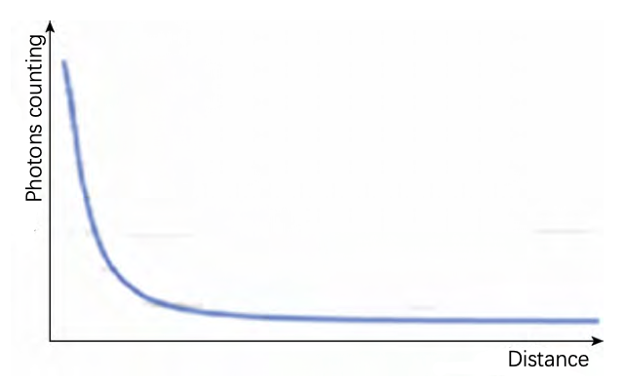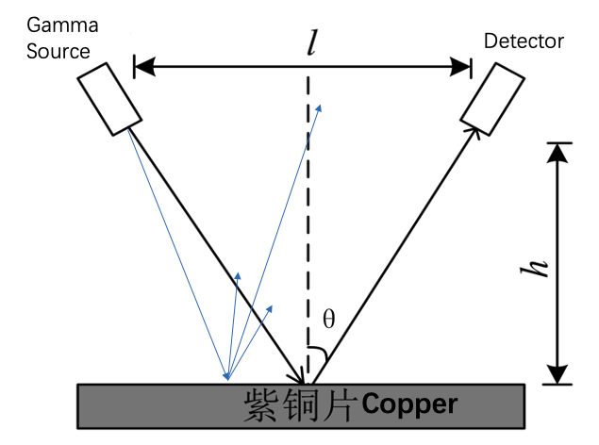

Figure 8. Photons counting corresponding to different distances. [3]

Figure 7. Experimental Apparatus Setup

#### 2.3 Procedure

To obtain an ‘I-h’ curve, we follow this experimental procedure for each copper distance :

1. Setting Up the Experiment - Mirror and Copper Orientation: Place the plain mirror directly in front of the copper plates and adjust the orientation of both the plain mirror and the copper plates using a laser pen positioned atop the gamma source. Ensure that emitted photons from the source effectively reach the detector.
2. Data Collection with the Software - Recording Gamma Ray Intensity: Utilize the Multichannel Data Processing Software to record the intensity of gamma rays received by the detector over a period of $T$ seconds, denoted as $I_{1}(E)$. It's important to note that the software provides a spectrum, indicating that $I_{1}(E)$ is a function of $E$.
3. Background Signal Measurement - Obtaining Detector's Background Signal: Remove the copper and repeat step (2) to obtain the background signal of the detector, referred to as $I_{0}(E)$.
4. Calculating Scattered Gamma Rays - Determining Intensity of Scattered Gamma Rays: Represent the intensity of reflected gamma rays as $I_{r}(E) = I_{1}(E) - I_{0}(E)$.
5. Total Intensity Calculation - Computing the Total Gamma Ray Intensity: Express the total intensity $I$ as an integral over $E$, i.e. $I =\int_{E_{1}}^{E_{2}}{I_{r}\left(E\right)}$ d $E$, where $[E_{1}, E_{2}]$ defines the energy range of reflected gamma photons that undergo Compton scattering. For our purposes, assume $[E_{1}, E_{2}]$ $=$ [0.13 MeV, 0.25 MeV].

## 2.4 Challenges and Solutions

#### 2.4.1 Data Correction for Lead Block Obstruction

As the distance decreased, lead blocks obstructed photons, reducing the number received by the probe. This required corrections for close-range scenarios.

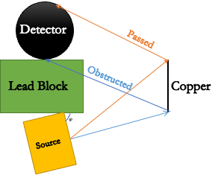

Figure 9. Photons reflected at specific angles are obstructed by the lead block.

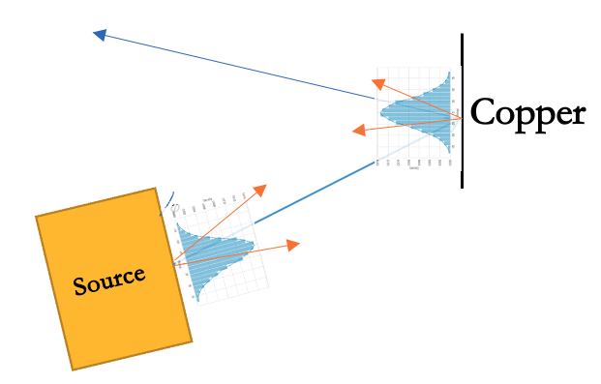

Figure 10. The intensity of gamma rays with respect to the emission angle θ follows a normalized distribution function f(θ).

However, challenges arise when attempting to accurately calculate the number of gamma photons obstructed by the block. The complexity of the experimental setup is a major factor, as it requires moving copper plates between different distances to obtain an 'I-h' curve. Furthermore, the emitted gamma rays are not collimated. The intensity of gamma rays, concerning the emission angle θ, conforms to a normalized distribution function denoted as f(θ). Likewise, the intensity of gamma rays reflected by the copper foil also adheres to a normalized distribution function represented by g(θ).

To gain a more intuitive understanding of the challenge associated with analytically calculating the number of obstructed photons, we embark on a derivation here. Let us set the stage by defining the pertinent variables:

First, we have the photon angle distribution originating from the source, denoted as $f(θ)$, and the photon angle distribution after reflection by a copper plate, expressed as $g(θ^{'})$.

If we consider photons that are reflected at angles falling within the range from $θ_{1}^{'}$ to $θ_{2}^{'}$ and subsequently reach a detector, we can formulate the number of received photons, $dN_{received}(θ)$, as follows:

$$dN_{received}\left(θ\right)=dN^{'}\left(θ\right)\int_{θ_{1}^{'}\left(θ\right)}^{θ_{2}^{'}\left(θ\right)}{g\left(θ^{'}\right)dθ^{'}}$$

Further integrating this expression, we obtain:

$$N_{received}=\int{\int_{θ_{1}^{'}(θ)}^{θ_{2}^{'}(θ)}{g\left(θ^{'}\right)dθ'}dN^{'}(θ) }=N_{0}\int{\int_{θ_{1}^{'}(θ)}^{θ_{2}^{'}(θ)}{g\left(θ^{'}\right)dθ'}f(θ)}dθ$$

Here, $θ$ signifies the angle of photon emission from the source, and it is important to note that both $θ_{1}^{'}, θ_{2}^{'}$ should be considered as functions of $θ$ and the distance of the copper plates.

In situations where no obstructions are present, it becomes necessary to rederive the expressions for $θ_{1}^{'}, θ_{2}^{'}$, thus highlighting the intricacies involved in this analytical pursuit.

#### 2.4.2 Data Correction for Finite Copper Size

In an actual spacecraft landing scenario, the land that reflects gamma rays can be approximated as infinitely vast. Nevertheless, our experimental copper sample is confined to finite dimensions, resulting in a diminished reflection of gamma photons. Therefore, the necessity arises for a correction to account for the infinite land conditions.

#### 2.4.3 Monte Carlo Method

The Monte Carlo Method, a versatile, precise, and time-efficient statistical technique, finds application in simulating photon emission and assessing photon obstructions by lead blocks. This method offers the flexibility to fine-tune particle number integration outcomes. Here is a breakdown of the method's procedure:

1. Modeling the Angular Distribution: The method employs a normal distribution to mathematically represent the angular distribution of emitted and reflected photons. In the case of emission, this distribution is expressed as $f\left(θ\right)=Ae^{-\frac{θ^{2}}{2σ^{2}}}, θ∈(-\frac{π}{2},\frac{π}{2})$, where $θ$ denotes the angle of emission, with $σ$ set to $\frac{π}{6}$ to ensure that the probability of $θ$ falling within the range of $(-\frac{π}{2}, \frac{π}{2})$ reaches a substantial 99.7%; in the case of reflection, it is represented as $g\left(θ^{'}\right)= Ae^{\frac{{\left(θ^{'}-θ_{0}\right)}^{2}}{2 σ^{2}}}$ with $θ_{0}$ being the incident angle and $θ^{'}$ the reflection angle.
2. Computer Simulation: A computer simulation is conducted to emulate the emission of photons based on the aforementioned angular distribution. This simulation rigorously evaluates the potential obstructions encountered by photons as they interact with lead blocks, taking into account the measured geometric relations.
3. Photon Quantity Assessment: The method tracks and records the quantity of photons that successfully reach the scintillation probe under two distinct conditions: one in the presence of the lead block with a finite-sized copper sample and the other in the absence of the lead block with an infinitely sized copper sample. These quantities are denoted as $N_{1}$ and $N_{2}$, respectively.
4. Integration Correction: To ensure the accuracy of the integral results derived directly from the Multichannel Data Processing Software, a correction is applied. This correction is implemented using the formula $N=\frac{N_{2}}{N_{1}}×N_{base}$.

## 3 Results and Discussion

#### 3.1 The I-h Curve

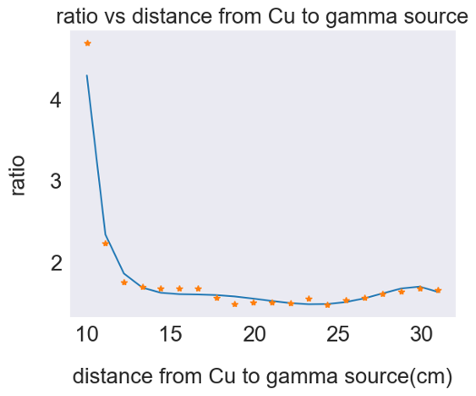After performing the aforementioned experimental procedure and integrating $I_{r}(E)$ over $E$, we derive an initial I-h curve, as illustrated in Figure 11. Furthermore, employing the Monte Carlo rectification method, we calculate a correction factor denoted as $\frac{N_{2}}{N_{1}}$, as depicted in Figure 12.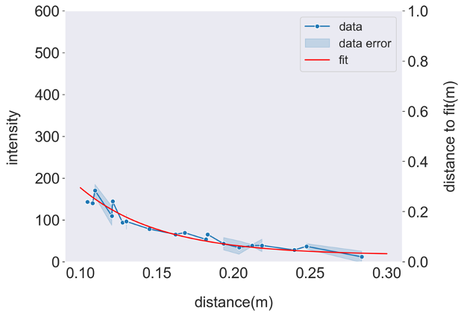

Figure 12. The curve of correction factor (ratio) varying with distance h.

Figure 11. Primordial I-h curve obtained directly from the experimental procedure.

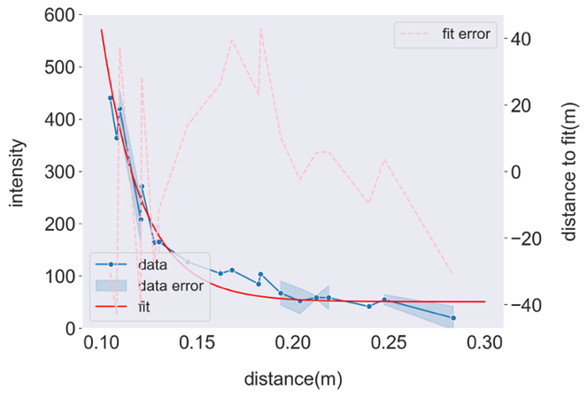Consequently, by multiplying the initial I-h curve by the correction factor, we obtain the rectified curve, which can be fitted and expressed as $y=43694e^{-44.2x}+48$, as shown in Figure 13. The fitted curve exhibits a relatively small error, with a maximum approximation of 40. This curve corresponds closely in terms of the exponential relationship to the curve obtained from the gamma photon altimeter measurements, depicted in Figure 4, which can be fitted and expressed as $y=132e^{-0.730x}+15$. Furthermore, the plot reveals that the gamma ray altimeter we have constructed exhibits remarkable precision within the range of [0.10 m, 0.15 m], where the 'I' curve experiences a rapid decrease, indicating the sensitivity of 'I' to 'h' within this specific range.

Figure 13. The rectified I-h curve.

#### 3.2 Ranging Earth Sample

We have obtained an earth sample with the specific purpose of utilizing it to mimic the terrestrial ground surface encountered during a spacecraft landing. This Earth sample is composed of distinct layers, encompassing loose leaves on the upper surface, soil beneath, and a sturdy stone slab at the base (refer to Figure 14). The leaves, owing to their loose arrangement, effectively simulate the non-load-bearing layers that cannot withstand the spacecraft's weight. In contrast, the soil and the stone slab exhibit greater rigidity, faithfully replicating the weight-bearing layers found on a genuine landing surface. It is noteworthy that these materials consist primarily of light atoms, such as hydrogen (H), carbon (C), oxygen (O), aluminum (Al), magnesium (Mg), and calcium (Ca). Consequently, when it comes to gamma ray interactions, Compton scattering prevails as the dominant mechanism among the three types of matter interactions.

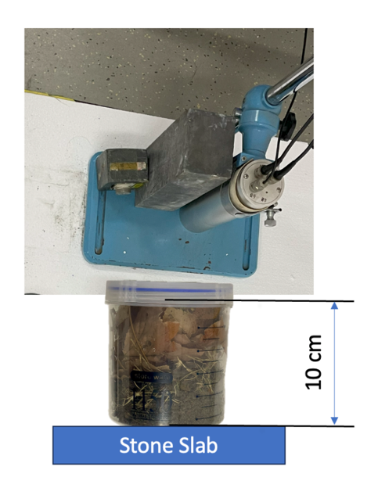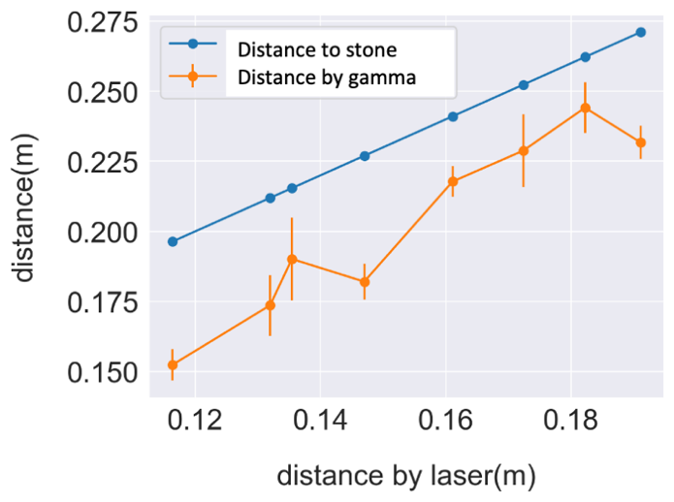After correctly positioning the earth sample and following the previously mentioned procedure, we obtained $I'$ as the intensity of gamma rays "reflected" (i.e., inversely scattered) by the sample. Using the 'I-h' curve we had previously obtained, we determined the distance of the sample to the detector ('h'). The relationships between the gamma ray-measured distance ('distance by gamma'), the distance to the stone slab ('distance to stone'), and the distance to the surface of leaves (referred to as 'distance by laser' because the laser reflects off the surface of the leaves) are illustrated in Figure 15.

Figure 14. Earth sample to be ranged.

Figure 15. The relation between 'distance by gamma', 'distance to stone' and 'distance by laser'.

As depicted in the figure, the inverse scattering of gamma photons in the earth sample can be equivalently represented as a reflection from the soil layer. Since the soil layer is considered weight-supportive, the gamma ray-ranging results accurately reflect the actual landing point.

## 4 Conclusion

The research presented herein confirms the viability of gamma ray ranging as a transformative approach for spacecraft landings. Despite encountering obstacles such as photon obstruction and the limited size of the copper reflector, the application of advanced corrective techniques like the Monte Carlo method has validated the effectiveness and reliability of this novel method. The corrected I-h curves underscore the enhanced precision achievable with gamma ray altimeters, paving the way for safer and more accurate space missions. This breakthrough in landing technology promises to contribute to the evolution of space exploration.

## 5 References

[1] Rutherford. The Scientific Monthly 34 [J], no. 6 (1932): 483–86.

[2] Wolfendale, Arnold. Nuclear Physics B-Proceedings Supplements 22 [J], no. 2 (1991): 80–85.

[3] 张楠,吴世通,沈超.γ源辐射角度对光子高度计性能的影响分析[J].航天返回与遥感,2014,35(06):37-41.

Zhang Nan, Wu Shitong, Shen Chao. Analysis of the influence of gamma source radiation angle on photon altimeter performance[J]. Spacecraft Recovery and Remote Sensing, 2014, 35(06): 37-41.

[4] 吴建云，王春杰，宋顺光. 月球着陆器典型故障模式分析. 宇航学报, 2014, 35(6): 633-639.

Wu Jianyun, Wang Chunjie, Song Shunguang. Analysis of typical failure modes of lunar landers. Journal of Astronautics, 2014, 35(6): 633-639.

[5] Der S, Redman B, Chellappa R. Applied Optics [J], 1997, 36(27): 6869-6874.

[6] Doerry A W. Radar Sensor Technology XVIII. SPIE [J], 2014, 9077: 492-503.

[7] Wang, Huiqun, and Mark I. Richardson. Icarus 251 (2015): 112–27.

[8] LIU J, SHEN C, WU S, et al. Correction method of the manned spacecraft low altitude ranging based on γ ray[J]. Aerospace Science and Technology, 2016, 50: 71–76